

Total Score:

Question

a)

b)

c)

d)

e)

f)

g)

h)

**ANL252**

**Python for Data Analytics**

# **Tutor-Marked Assignment**

**July 2021 Presentation**

**Submitted by:**

|  |  |
| --- | --- |
| **Name** | **PI No.** |
| **Amir Hamzah Bin Abdul Khalid** | **B2110864** |

**Tutorial Group: ­­­­­­­­­­­­ T 09**

**Instructor’s Name: Dr. Munish Kumar**

**Submission Date: 15/08/2021**



Figure 0.1 – Embedded python code for Tutor Marked Assignment.

1. Program code:

import math as m

Figure 1.1 – Screenshot of Python software with ‘math’ package installed.

1. Program code:

main = print ("Welcome to the probability density function Program. \nThis program allows you to compute the probability of a normally distributed random variable \ngiven the distribution mean and variance.")

print ("Please follow the instructions below...")

M = float(input("Please enter the mean:") or "0")

if M == "":

M = 0

print (f"You are unsure of the mean, thus it is {M}")

else:

print (f"Your mean is {M}")

V = float(input("Please enter the variance:") or "1")

if V == "":

V = 1

print (f"You are unsure of the variance, thus it is {V}")

else:

print (f"Your variance {V}")

1. Program code:

Xx = float(input("Please enter the value of X: "))

print(f"Your value of X is {Xx}")

print(f"In summary... \nMean = {M} \nVariance = {V} \nX = {Xx}")

1. Program code:

import math as m

fx = float((1/(m.sqrt(2*m.pi*V)))**(-((Xx-M)**2)/(2*V)))

1. Program code:

print (f"fx = {fx}")

1. Program code:

alpha = 0.01

a = -100

Q = (a-alpha)

P = ((Q-alpha)/(a*fx))

print (f"P = {P}")

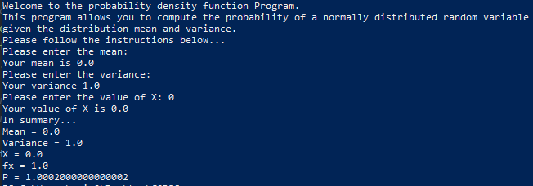

Figure 1.2 – Screenshot of program when k = 0

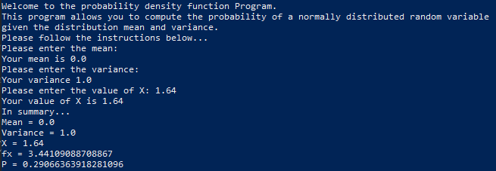

Figure 1.3 – Screenshot of program when k = 1.64

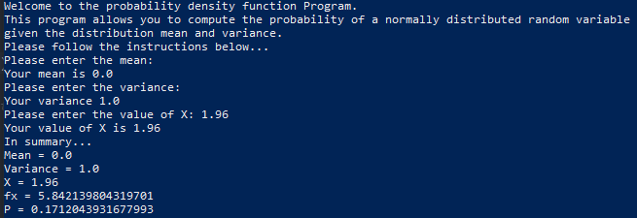

Figure 1.4 – Screenshot of program when k = 1.96

1. The program defines ‘Q’ as the value of ‘a’ minus ‘α’. After which, ‘P’ is defined as the calculation of value ‘Q’ minus ‘α’ divided by ‘a’ multiplied by ‘fx’.